|  |  |  |  |  |  |
| --- | --- | --- | --- | --- | --- |
| Task: | |  |  |  |  | | --- | --- | --- | --- | |  | Manage Receivables Descriptive Flexfields  Line Transactions  VbcsInvoiceId – 30 Chars  VbcsInvoiceLineId |  |  | |

Segment: LineNumber

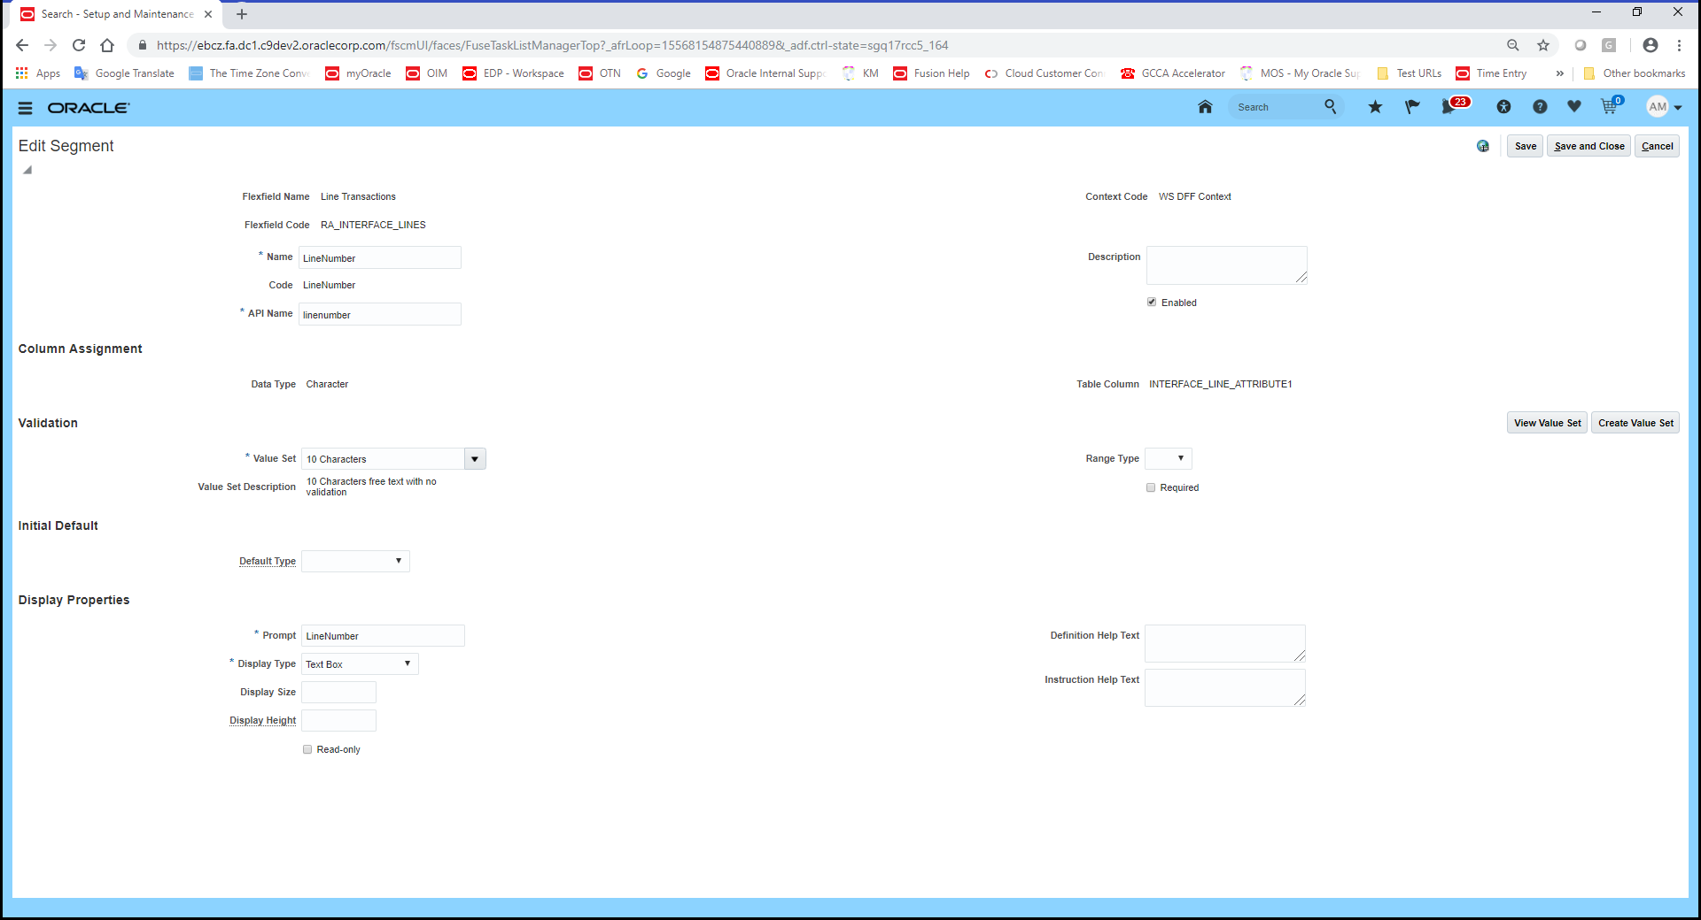

Segment: sourceNum

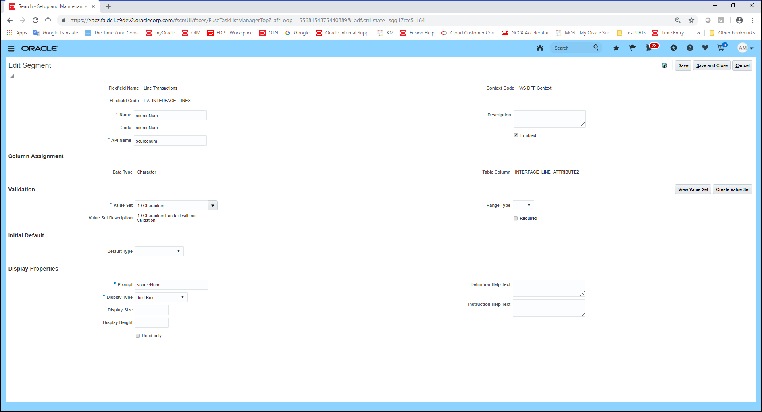

After WS execution:

Data from ra_interface_lines_all

